 | 
Local Insight England Summary Report  Guildford 007C  Surrey County Council  22 July 2024 | 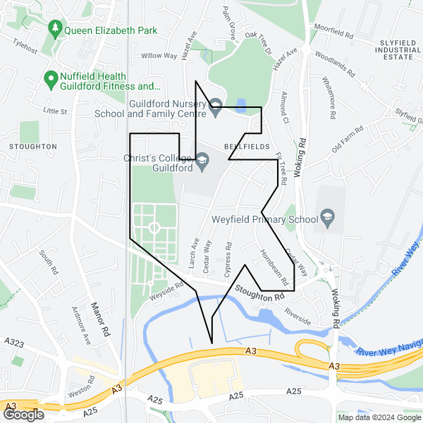

Local Insight
Local Insight provides instant access to the information you need for the neighbourhoods you care about.
We bring together small-area social and demographic data in one easy to use and intuitive platform. You can explore data for any area you are interested in through maps, dashboards and reports.
Find out more at: localinsight.org

OCSI
We combine expertise in research and technology to support organisations working for social good to make evidence-based decisions. We have worked with more than 250 public and community sector organisations from local to international level.
Our research and services are based on unrivalled knowledge and use of place-based social, economic and demographic data.
Find out more at: ocsi.uk

About the indicators
OCSI routinely collect all small-area data published by more than 50 government agencies and other reputable bodies. We identify key indicators relevant to local authorities, grantmakers and charities to include within this report and the Local Insight platform.
We manage and maintain all the data and provide comprehensive metadata so that you can be confident you are using the most up-to-date data.

How we have identified the area of Guildford 007C
This report is based on the “Guildford 007C” area created by Surrey County Council. There is a map image of the area at the start of this report. Source: Office for National Statistics licensed under the Open Government Licence v.3.0. Contains OS data © Crown copyright and database right [2024].
We use sophisticated aggregation and apportioning methods to calculate the data values used in the charts and tables in this report.
Alongside data for the “Guildford 007C” area, we also display data for the selected comparator areas: Guildford and Surrey.

Contents
Population
Unemployment
Housing
Crime
Health
Education
Employment
Communities and Environment
Access and Transport
Appendix: Data sources

Population
The following data is a summary of key population demographics.
The table below provides an overview of people living in Guildford 007C. These population figures provide detail of the structure of the population by broad age bands and by sex. Finally, it also includes a measure of population density by hectare.
The total population of Guildford 007C was 1,478 people in 2021.
Of the total population in Guildford 007C in 2021, 19.42% are children aged under 16, 65.02% are adults aged 16-64, and 15.56% are over 65 years old.

Population overview
Indicator | Guildford 007C |  | Guildford |  | Surrey
 | Count | Rate | Count | Rate | Count | Rate
All people (Census 2021) (2021) | 1,478 | - | 143,649 | - | 1,203,108 | -
All Females (Census 2021) (2021) | 733 | 49.59% | 72,929 | 50.77% | 616,067 | 51.21%
All Males (Census 2021) (2021) | 745 | 50.41% | 70,720 | 49.23% | 587,041 | 48.79%
Population aged under 16 (Census 2021) (2021) | 287 | 19.42% | 24,294 | 16.91% | 230,595 | 19.17%
Population aged 16 to 64 (Census 2021) (2021) | 961 | 65.02% | 94,198 | 65.58% | 745,323 | 61.95%
Population aged 65+ (Census 2021) (2021) | 230 | 15.56% | 25,158 | 17.51% | 227,190 | 18.88%
Population Density (Persons per sq km) (Census 2021) (2021) | 1,478 | 3,621.53 | 143,649 | 530.20 | 1,203,108 | 720.40
Source: UK Census

Index of Multiple Deprivation (IMD)

The following visualisations draw upon data from the Index of Multiple Deprivation (IMD) to give insight into vulnerable populations in Guildford 007C, Guildford, Surrey. The Indices of Deprivation 2019 are a relative measure of deprivation for small areas (Lower-layer Super Output Areas) across England. The overall Index of Multiple Deprivation 2019 combines together indicators under seven different domains of deprivation: Income Deprivation; Employment Deprivation; Education Skills and Training Deprivation; Health Deprivation and Disability; Crime; Barriers to Housing and Services and Living Environment Deprivation. A higher score indicates that an area is experiencing high levels of deprivation.
The table below shows the IMD score and rank (average LSOA Rank, where a lower rank indicates that an area is experiencing high levels of deprivation) for Guildford 007C, Guildford and Surrey.
Guildford 007C has an IMD score of 33.32. This means that Guildford 007C has higher levels of deprivation to Guildford (9.40) and higher levels of deprivation to Surrey (10.08).

Index of Multiple Deprivation (IMD)
Indicator | Guildford 007C | Guildford | Surrey
Index of Multiple Deprivation 2019 (IMD) Score (2019) | 33.32 | 9.40 | 10.08
Index of Multiple Deprivation (IMD) 2019 Rank (2019) | 6,539 | 25,578 | 24,931
Source: Ministry of Housing Communities and Local Government (MHCLG) 2019

The bar chart below explores this further, showing the proportion of people living in neighbourhoods grouped into deciles according to level of deprivation derived from the IMD. A higher score on the IMD indicates that an area is experiencing greater levels of deprivation. To clarify, all neighbourhoods in England are grouped into ten equal sized groups “deciles”; neighbourhoods in decile 1 fall within the most deprived 10% of neighbourhoods nationally, whilst neighbourhoods in decile 10 fall within the least deprived 10% of neighbourhoods nationally.

Proportion of people in each deprivation decile
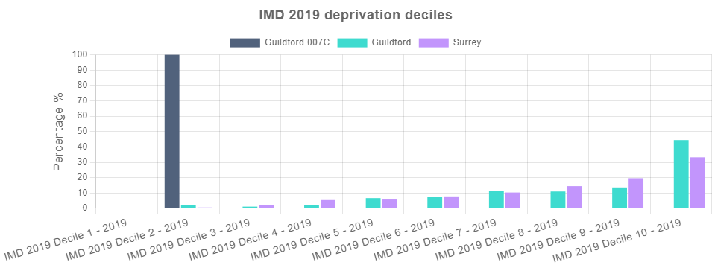
Source: Ministry of Housing Communities and Local Government (MHCLG) 2019

Unemployment
The following data shows the key unemployment indicators.
The table below shows the total number and proportion of people receiving Universal Credit (UC) or Job Seekers Allowance (JSA) by age and sex. The proportion of working age people receiving benefits for unemployment in Guildford 007C was 5.33% in May-2024. This is higher than the average across Guildford (1.92%) and higher than the average across Surrey (2.16%).

Unemployment Benefit Claimants
Indicator | Guildford 007C |  | Guildford |  | Surrey
 | Count | Rate | Count | Rate | Count | Rate
Unemployment benefit claimants (Jobseekers Allowance and out of work Universal Credit claimants) (May-2024) | 50 | 5.33% | 1,830 | 1.92% | 16,160 | 2.16%
Youth unemployment (18-24 receiving JSA or Universal Credit) (May-2024) | 10 | 6.85% | 290 | 1.55% | 2,410 | 2.69%
Older person unemployment (50+ receiving JSA or Universal Credit) (May-2024) | 15 | 2.69% | 480 | 0.91% | 4,160 | 0.87%
Unemployment benefit (JSA and Universal Credit), female (May-2024) | 25 | 5.53% | 790 | 1.65% | 7,525 | 1.98%
Unemployment benefit (JSA and Universal Credit), male (May-2024) | 30 | 6.17% | 1,040 | 2.19% | 8,635 | 2.34%
Source: Department for Work and Pensions (DWP)

The chart below shows the total proportion of people receiving unemployment benefit (JSA or Universal Credit) between Jan-2020 and May-2024.
The total unemployment rate in Guildford 007C has increased from 2.61% in Jan-2020 to 5.33% in May-2024.

Unemployment Benefit Claimants (time series)
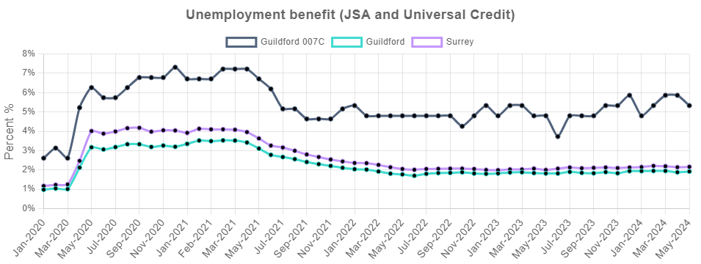
Source: Department for Work and Pensions (DWP)

Housing
The following data is a summary of key housing related indicators.
The table below shows the mean house prices by accommodation type across Guildford 007C and the comparator areas for four key dwelling types (flats, semi-detached houses, terraced houses and detached houses) from Mar-2023 to Feb-2024.
The average property price for all dwelling types in Guildford 007C is £428,278, this is lower than the average across Guildford (£624,854) and lower than the average across Surrey (£640,012).
Data on house prices is from the Land Registry open data price-paid dataset Please note some small areas may not have had a transaction recorded within the twelve month period leading to gaps in the table below.

Average house prices
Indicator | Guildford 007C | Guildford | Surrey
Average house price (12 months) (Mar-2023 to Feb-2024) | £428,278 | £624,854 | £640,012
Average house price for detached houses (12 months) (Mar-2023 to Feb-2024) | - | £1,056,420 | £1,080,638
Average house price for flats (12 months) (Mar-2023 to Feb-2024) | - | £297,829 | £303,184
Average house price for semi-detached houses (12 months) (Mar-2023 to Feb-2024) | £430,500 | £526,950 | £562,344
Average house price for terraced houses (12 months) (Mar-2023 to Feb-2024) | £427,643 | £445,694 | £472,631
Source: UK Land Registry

The chart below shows the tenure of housing in Guildford 007C, Guildford, and Surrey.
Tenure types include;
- ‘Owner occupied’ housing includes accommodation that is either owned outright, owned with a mortgage or loan, or shared ownership (paying part rent and part mortgage).
- ‘Social rented’ housing includes accommodation that is rented from a council (Local Authority) or a Housing Association, Housing Co-operative, Charitable Trust, Non-profit housing company or Registered Social Landlord.
- ‘Rented from the Council includes accommodation rented from the Local Authority.
- ‘Housing Association or Social Landlord’ includes rented from Registered Social Landlord, Housing Association, Housing Co-operative, Charitable Trust and non-profit housing Company.
- ‘Private rented or letting agency’ includes accommodation that is rented from a private landlord or letting agency.
- ‘Other Rented’ includes employer of a household member and relative or friend of a household member and living rent free.

In Guildford 007C 34.82% of households are owner-occupied, which is lower than the proportion of households in Guildford (67.63%), and a lower proportion than Surrey (71.67%).
Overall, 44.55% of households in Guildford 007C are rented from the local authority, 7.76% are rented from a housing association and 9.90% are privately rented.

Housing tenure
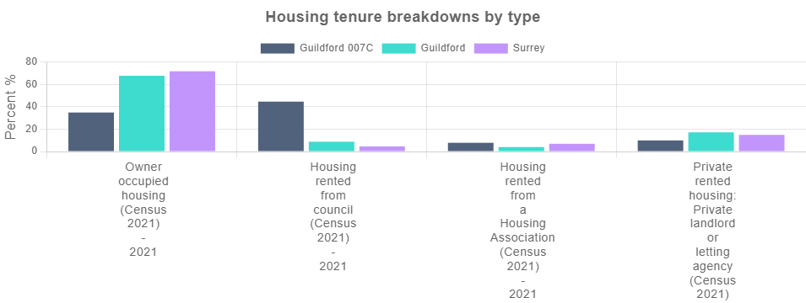
Source: UK Census

Crime
The information below shows the level of recorded crime in Guildford 007C and comparator areas. This is based on data for individual crime incidents published via the Police UK open data portal, which has been linked by Local Insight to selected neighbourhoods.
The table below shows counts and rates for the main crime types and anti-social behaviour incidents between Mar-2023 to Feb-2024.
There were 264 total crime offences in Guildford 007C between Mar-2023 to Feb-2024, with the overall crime rate being 180.9 per 1,000 population. This is higher than the average across Guildford (124.5) and higher than the average across Surrey (100.5).

Crime and Anti-Social Behaviour Incidents
Indicator | Guildford 007C |  | Guildford |  | Surrey
 | Count | Rate | Count | Rate | Count | Rate
Total crime offences (12 month total) (Mar-2023 to Feb-2024) | 264 | 180.9 | 18,140 | 124.5 | 122,098 | 100.5
Anti-social behaviour (12 month total) (Mar-2023 to Feb-2024) | 23 | 15.8 | 2,731 | 18.7 | 19,419 | 16.0
Bicycle theft offences (12 month total) (Mar-2023 to Feb-2024) | 0 | 0.0 | 236 | 1.6 | 1,643 | 1.4
Burglary (12 month total) (Mar-2023 to Feb-2024) | 7 | 11.5 | 566 | 10.2 | 4,707 | 9.8
Criminal damage (12 month total) (Mar-2023 to Feb-2024) | 31 | 21.2 | 1,517 | 10.4 | 10,381 | 8.5
Drug crime offences (12 month total) (Mar-2023 to Feb-2024) | 13 | 8.9 | 416 | 2.9 | 3,053 | 2.5
Other crime offences (12 month total) (Mar-2023 to Feb-2024) | 12 | 8.2 | 337 | 2.3 | 2,254 | 1.9
Other theft offences (12 month total) (Mar-2023 to Feb-2024) | 14 | 9.6 | 1,356 | 9.3 | 9,845 | 8.1
Shoplifting offences (12 month total) (Mar-2023 to Feb-2024) | 3 | 2.1 | 1,635 | 11.2 | 6,894 | 5.7
Possession of weapons offences (12 month total) (Mar-2023 to Feb-2024) | 3 | 2.1 | 135 | 0.9 | 912 | 0.8
Public order offences (12 month total) (Mar-2023 to Feb-2024) | 19 | 13.0 | 1,843 | 12.7 | 11,238 | 9.3
Robbery recorded offences (12 month total) (Mar-2023 to Feb-2024) | 1 | 0.7 | 109 | 0.7 | 652 | 0.5
Theft from the person offences (12 month total) (Mar-2023 to Feb-2024) | 0 | 0.0 | 132 | 0.9 | 685 | 0.6
Vehicle crime (12 month total) (Mar-2023 to Feb-2024) | 29 | 19.9 | 1,093 | 7.5 | 9,538 | 7.9
Violent crime and sexual offences (12 month total) (Mar-2023 to Feb-2024) | 109 | 74.7 | 6,034 | 41.4 | 40,877 | 33.7
Source: Police UK (Police recorded crime figures)

The line chart below shows a time series made up of 12 month totals of neighbourhood-level incidents of criminal offences. The figure is a rate per 1,000 residents. The first data point covers Sep-2018 to Aug-2019 and the final data point covers Mar-2023 to Feb-2024.
The overall crime rate in Guildford 007C has increased from 108.0 per 1,000 people between Sep-2018 to Aug-2019 to 180.9 per 1,000 people between Mar-2023 to Feb-2024.
Please note there can be missing data in Police.uk crime counts for certain areas. This is often due to issues with IT system changes at various police forces such as Devon and Cornwall, and Greater Manchester currently, which affects their reporting of figures to Police UK. Please see the Police UK change log for details of current known issues.

12 month total crime rate (time series)
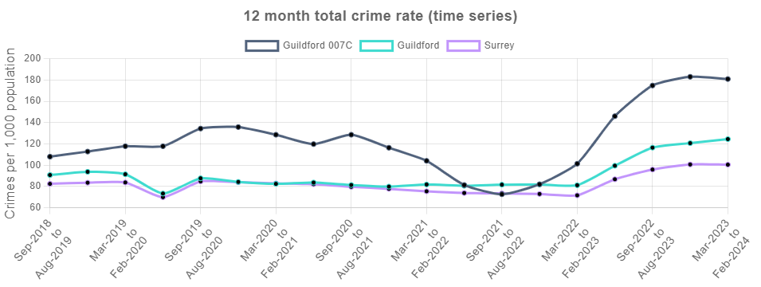
Source: Police UK

Health
The following data provides an overview of people's health with the first table below providing some key health statistics.
There are 160 people in Guildford 007C who are disabled under the equality act and whose day to day activities are limited a lot. This is 10.82% of the working population, which is higher than Guildford (4.68%) and higher than Surrey (5.14%).
In regards to the provision of unpaid care, there are 65 people in Guildford 007C providing 50+ hours of unpaid care a week. This is 4.69% of the working population, which is higher than Guildford (1.94%) and higher than Surrey (2.06%)

Key health statistics
Indicator | Guildford 007C |  | Guildford |  | Surrey
 | Count | Rate | Count | Rate | Count | Rate
Disabled under the Equality Act: Day-to-day activities limited a lot (Census 2021) (2021) | 160 | 10.82% | 6,725 | 4.68% | 61,835 | 5.14%
Disabled under the Equality Act: Day-to-day activities limited a little (Census 2021) (2021) | 181 | 12.24% | 12,791 | 8.90% | 104,266 | 8.67%
Not disabled under the Equality Act: Has long term physical or mental health condition but day-to-day activities are not limited (Census 2021) (2021) | 93 | 6.29% | 11,194 | 7.79% | 89,595 | 7.45%
Not disabled under the Equality Act: No long term physical or mental health conditions (Census 2021) (2021) | 1,045 | 70.66% | 112,941 | 78.62% | 947,410 | 78.75%
Very good health (Census 2021) (2021) | 593 | 40.15% | 78,671 | 54.77% | 649,544 | 53.99%
Good health (Census 2021) (2021) | 536 | 36.29% | 46,690 | 32.50% | 391,018 | 32.50%
Very bad health (Census 2021) (2021) | 33 | 2.23% | 1,041 | 0.72% | 9,000 | 0.75%
Bad health (Census 2021) (2021) | 81 | 5.48% | 3,531 | 2.46% | 31,378 | 2.61%
No unpaid care (Census 2021) (2021) | 1,238 | 89.26% | 126,502 | 92.36% | 1,046,976 | 92.04%
50+ hours unpaid care a week (Census 2021) (2021) | 65 | 4.69% | 2,657 | 1.94% | 23,469 | 2.06%
Children providing unpaid care (Census 2021) (2021) | 7 | 2.44% | 254 | 1.05% | 2,168 | 0.94%
Source: UK Census

The chart below shows the most recent number of Personal Independent Payment claimants.
A higher proportion of people in Guildford 007C are claiming Personal Independence Payment (13.43%) than in Guildford (4.09%) and a higher proportion than in Surrey (4.68%).

Personal Independence Payment (PIP) Claimants
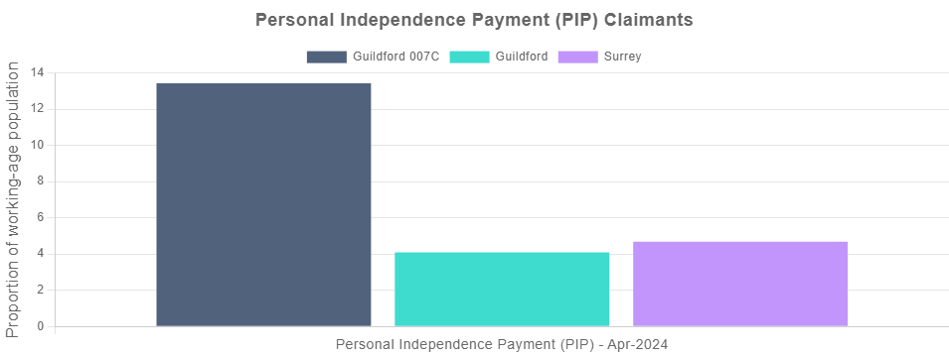
Source: Department for Work and Pensions (DWP)

Education
The following data is a summary of the key indicators related to education.
The table below shows the distribution of qualification levels and the subsequent bar chart shows a comparison of those with no qualifications besides those with degree level qualifications or higher.
There are 334 people in Guildford 007C with no qualifications, which is 28.00% of all people aged over 16. This is higher than the average for Guildford (11.34%) and higher than the average in Surrey (12.86%).
There are 262 people with degree level qualifications in Guildford 007C, which is 21.96% of people aged 16+. This is lower than the average in Guildford (44.09%) and lower than the average in Surrey (42.36%).

Level of qualification
Indicator | Guildford 007C |  | Guildford |  | Surrey
 | Count | Rate | Count | Rate | Count | Rate
People with no qualifications (Census 2021) (2021) | 334 | 28.00% | 13,540 | 11.34% | 125,027 | 12.86%
Highest level of qualification: Apprenticeship (Census 2021) (2021) | 80 | 6.71% | 4,686 | 3.93% | 40,761 | 4.19%
Highest level of qualification: Other qualifications (Census 2021) (2021) | 44 | 3.69% | 2,783 | 2.33% | 24,572 | 2.53%
Highest level of qualification: Level 1 qualifications (Census 2021) (2021) | 142 | 11.90% | 8,646 | 7.24% | 82,079 | 8.44%
Highest level of qualification: Level 2 qualifications (Census 2021) (2021) | 148 | 12.41% | 13,528 | 11.33% | 127,462 | 13.11%
Highest level of qualification: Level 3 qualifications (Census 2021) (2021) | 183 | 15.34% | 23,554 | 19.73% | 160,632 | 16.52%
Highest level of qualification: Level 4/5 (degree or higher) qualifications (Census 2021) (2021) | 262 | 21.96% | 52,620 | 44.09% | 411,979 | 42.36%
Source: UK Census

No qualifications or degree level and above
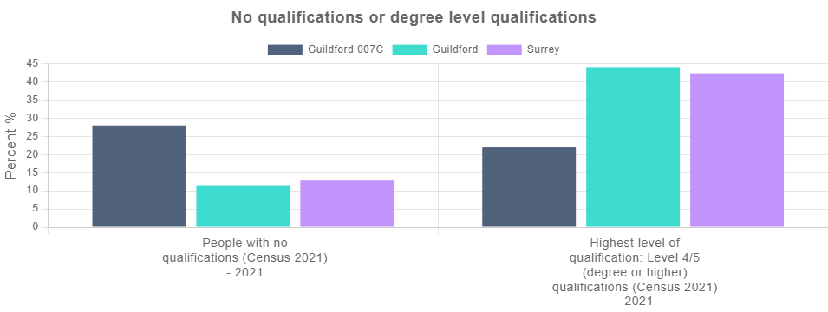
Source: UK Census

Employment
The following data is a summary of key indicators related to employment.
The table below shows figures for the number of people that hold either full or part-time roles alongside the figures for those working in either the public or private sectors.
A lower proportion of people in Guildford 007C work in the private sector (18.52%) than the public sector (81.48%). People are more likely to be part-time employed in Guildford 007C (41.67%) than in Guildford (31.33%) and more likely than in Surrey (32.81%).

Jobs by type
Indicator | Guildford 007C | Guildford | Surrey
Full-time employees (2022) | 66.67% | 68.67% | 67.19%
Part-time employees (2022) | 41.67% | 31.33% | 32.81%
Public sector employees (2022) | 81.48% | 18.62% | 12.72%
Private sector employees (2022) | 18.52% | 81.38% | 87.28%
Source: Business Register and Employment Survey (BRES)

The jobs density (calculated as the number of jobs per 100 working-age people) in Guildford 007C was 37.31% in 2022. This is lower than the average across Guildford (90.38%) and lower than the average across Surrey (78.60%).

Jobs density
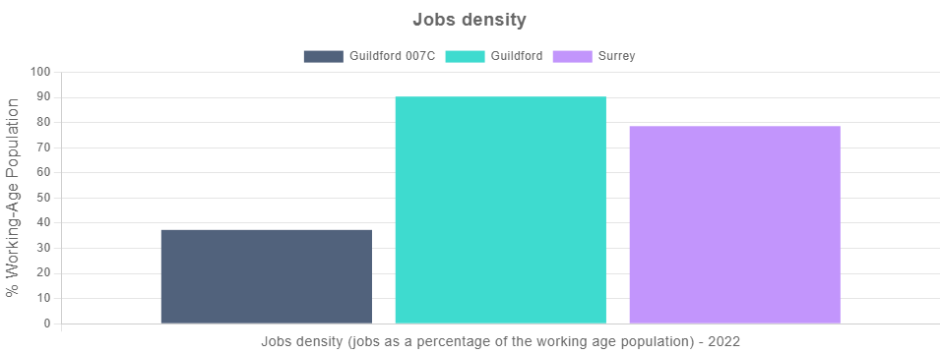
Source: Business Register and Employment Survey (BRES)

Communities and Environment
The following data is a summary of key indicators related to the community and environment.
The first chart below shows the overall rank on the 2023 Community Needs Index (CNI), as well as a rank on each of the three CNI domains for Guildford 007C, Guildford and Surrey.
The CNI was developed to identify areas experiencing poor community and civic infrastructure, relative isolation and low levels of participation in community life. The index was created by combining a series of 28 indicators, conceptualised under three domains: Civic Assets, Connectedness and Active and Engaged Community. A lower rank indicates that an area has relatively higher levels of need.<ul><li>
Civic Assets: measures the presence of key community, civic, educational and cultural assets in a close proximity of the area. These include pubs, libraries, green space, community centres, swimming pools – facilities that provide things to do often, at no or little cost, which are important to how positive a community feels about its area.</li><li>
Connectedness: measures the connectivity to key services, digital infrastructure, isolation and strength of the local jobs market. It looks at whether residents have access to key services, such as health services, within a reasonable travel distance. It considers how good public transport and digital infrastructure are and how strong the local job market is.</li><li>
Active and Engaged Community: measures the levels of third sector civic and community activity and barriers to participation and engagement. It shows whether charities are active in the area, and whether people appear to be engaged in the broader civic life of their community.</li></ul>
Guildford 007C has an overall CNI rank of 16,218. This means that Guildford 007C has higher levels of community need than Guildford (26,305) and higher levels of community need than Surrey (23,790).

CNI Rank
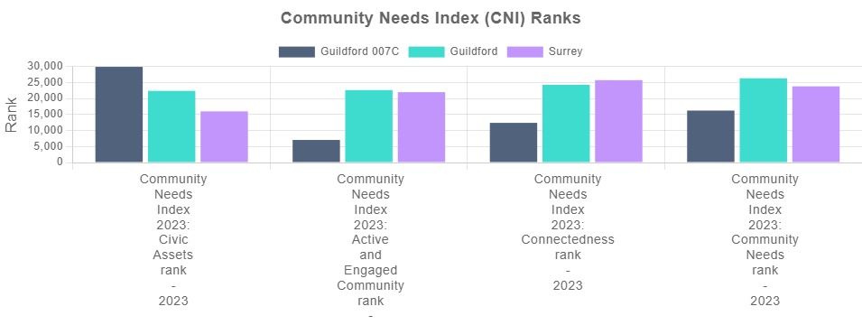
Source: Oxford Consultants for Social Inclusion (OCSI)

The table below shows the Indices of Deprivation Air Quality Measures. For each pollutant the atmospheric concentration was compared to a national standard value, with the concentrations in each Lower-layer Super Output Area divided by the appropriate national standard, before summing to produce a single indicator. A higher score indicates that an area is experiencing relatively higher levels of deprivation.
Based on the IoD 2019 Air quality indicator - Guildford 007C has higher levels of air pollution (1.080 IoD score) than Guildford (0.946 IoD score) and higher levels of air pollution than Surrey (0.982 IoD score).

Indices of Deprivation Air Quality Measures
Indicator | Guildford 007C | Guildford | Surrey
IoD 2019 Air quality indicator (2016) | 1.080 | 0.946 | 0.982
IoD 2019 Benzene (component of air quality indicator) (2016) | 0.120 | 0.100 | 0.105
IoD 2019 Nitrogen dioxide (component of air quality indicator) (2016) | 0.490 | 0.411 | 0.431
IoD 2019 Particulates (component of air quality indicator) (2016) | 0.440 | 0.409 | 0.419
IoD 2019 Sulphur dioxide (component of air quality indicator) (2016) | 0.030 | 0.027 | 0.028
IoD 2019 Road traffic accidents indicator (2015 to 2016) | 0.585 | 0.774 | 0.901
Source: Ministry of Housing Communities and Local Government (MHCLG)

Access and Transport
The following data is a summary of the main access and transport related indicators.
The table below shows the proportion of households according to their ownership of a car or van. This is based on responses to the car ownership question in the 2021 Census which asks information on the number of cars or vans owned, or are available for use, by one or more members of a household. This includes company cars and vans available for private use and is based on details for private households only. Cars or vans used by residents of communal establishments are not counted.
In Guildford 007C, 24.22% of households have no access to a car or van. This is greater than the proportion without access to a car or van in Guildford (13.83%) and greater than the proportion without access to a car or van in Surrey (12.71%).

Car or van ownership
Indicator | Guildford 007C | Guildford | Surrey
Households with no car (Census 2021) (2021) | 24.22% | 13.83% | 12.71%
1 car or van in household (Census 2021) (2021) | 43.82% | 38.83% | 40.43%
2 cars or vans in household (Census 2021) (2021) | 23.56% | 33.62% | 33.20%
Households with 3+ cars (Census 2021) (2021) | 8.40% | 13.73% | 13.65%
Source: UK Census

The bar chart below shows the proportion of households with no car or van in the 2021 Census alongside the proportions from previous Censuses to identify changes over time.
In 2011, 28.79% of households in Guildford 007C had no access to a car or van. This is greater than the proportion without access to a car or van in 2021 (24.22%).

Households with no car or van
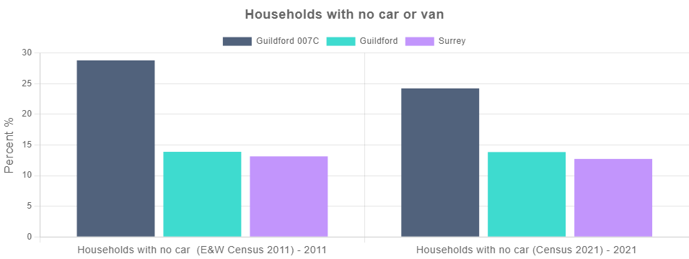
Source: UK Census

Appendix: Data sources

Theme | Data | Data source / time period
Population | All people (Census 2021) | Census 2021 (2021)
Population | All Females (Census 2021) | Census 2021 (2021)
Population | All Males (Census 2021) | Census 2021 (2021)
Population | Population aged under 16 (Census 2021) | Census 2021 (2021)
Population | Population aged 16 to 64 (Census 2021) | Census 2021 (2021)
Population | Population aged 65+ (Census 2021) | Census 2021 (2021)
Population | Population Density (Persons per sq km) (Census 2021) | Census 2021 (2021)
Population | Index of Multiple Deprivation 2019 (IMD) Score | Ministry of Housing Communities and Local Government (MHCLG) (2019)
Population | Index of Multiple Deprivation (IMD) 2019 Rank | Ministry of Housing Communities and Local Government (MHCLG) (2019)
Population | IMD 2019 Decile 1 | Communities and Local Government (CLG) (2019)
Population | IMD 2019 Decile 2 | Communities and Local Government (CLG) (2019)
Population | IMD 2019 Decile 3 | Communities and Local Government (CLG) (2019)
Population | IMD 2019 Decile 4 | Communities and Local Government (CLG) (2019)
Population | IMD 2019 Decile 5 | Communities and Local Government (CLG) (2019)
Population | IMD 2019 Decile 6 | Communities and Local Government (CLG) (2019)
Population | IMD 2019 Decile 7 | Communities and Local Government (CLG) (2019)
Population | IMD 2019 Decile 8 | Communities and Local Government (CLG) (2019)
Population | IMD 2019 Decile 9 | Communities and Local Government (CLG) (2019)
Population | IMD 2019 Decile 10 | Communities and Local Government (CLG) (2019)
Unemployment | Unemployment benefit claimants (Jobseekers Allowance and out of work Universal Credit claimants) | Department for Work and Pensions (DWP) (May-2024)
Unemployment | Youth unemployment (18-24 receiving JSA or Universal Credit) | Department for Work and Pensions (DWP) (May-2024)
Unemployment | Older person unemployment (50+ receiving JSA or Universal Credit) | Department for Work and Pensions (DWP) (May-2024)
Unemployment | Unemployment benefit (JSA and Universal Credit), female | Department for Work and Pensions (DWP) (May-2024)
Unemployment | Unemployment benefit (JSA and Universal Credit), male | Department for Work and Pensions (DWP) (May-2024)
Unemployment | Unemployment benefit claimants (Jobseekers Allowance and out of work Universal Credit claimants) | Department for Work and Pensions (DWP) (Jan-2020)
Housing | Average house price (12 months) | Land Registry (Mar-2023 to Feb-2024)
Housing | Average house price for detached houses (12 months) | Land Registry (Mar-2023 to Feb-2024)
Housing | Average house price for flats (12 months) | Land Registry (Mar-2023 to Feb-2024)
Housing | Average house price for semi-detached houses (12 months) | Land Registry (Mar-2023 to Feb-2024)
Housing | Average house price for terraced houses (12 months) | Land Registry (Mar-2023 to Feb-2024)
Housing | Owner occupied housing (Census 2021) | Census 2021 (2021)
Housing | Housing rented from council (Census 2021) | Census 2021 (2021)
Housing | Housing rented from a Housing Association (Census 2021) | Census 2021 (2021)
Housing | Private rented housing: Private landlord or letting agency (Census 2021) | Census 2021 (2021)
Crime | Total crime offences (12 month total) | Police UK (Mar-2023 to Feb-2024)
Crime | Anti-social behaviour (12 month total) | Police UK (Mar-2023 to Feb-2024)
Crime | Bicycle theft offences (12 month total) | Police UK (Mar-2023 to Feb-2024)
Crime | Burglary (12 month total) | Police UK (Mar-2023 to Feb-2024)
Crime | Criminal damage (12 month total) | Police UK (Mar-2023 to Feb-2024)
Crime | Drug crime offences (12 month total) | Police UK (Mar-2023 to Feb-2024)
Crime | Other crime offences (12 month total) | Police UK (Mar-2023 to Feb-2024)
Crime | Other theft offences (12 month total) | Police UK (Mar-2023 to Feb-2024)
Crime | Shoplifting offences (12 month total) | Police UK (Mar-2023 to Feb-2024)
Crime | Possession of weapons offences (12 month total) | Police UK (Mar-2023 to Feb-2024)
Crime | Public order offences (12 month total) | Police UK (Mar-2023 to Feb-2024)
Crime | Robbery recorded offences (12 month total) | Police UK (Mar-2023 to Feb-2024)
Crime | Theft from the person offences (12 month total) | Police UK (Mar-2023 to Feb-2024)
Crime | Vehicle crime (12 month total) | Police UK (Mar-2023 to Feb-2024)
Crime | Violent crime and sexual offences (12 month total) | Police UK (Mar-2023 to Feb-2024)
Crime | Total crime offences (12 month total) | Police UK (Sep-2018 to Aug-2019)
Health | Disabled under the Equality Act: Day-to-day activities limited a lot (Census 2021) | Census 2021 (2021)
Health | Disabled under the Equality Act: Day-to-day activities limited a little (Census 2021) | Census 2021 (2021)
Health | Not disabled under the Equality Act: Has long term physical or mental health condition but day-to-day activities are not limited (Census 2021) | Census 2021 (2021)
Health | Not disabled under the Equality Act: No long term physical or mental health conditions (Census 2021) | Census 2021 (2021)
Health | Very good health (Census 2021) | Census 2021 (2021)
Health | Good health (Census 2021) | Census 2021 (2021)
Health | Very bad health (Census 2021) | Census 2021 (2021)
Health | Bad health (Census 2021) | Census 2021 (2021)
Health | No unpaid care (Census 2021) | Census 2021 (2021)
Health | 50+ hours unpaid care a week (Census 2021) | Census 2021 (2021)
Health | Children providing unpaid care (Census 2021) | Census 2021 (2021)
Health | Personal Independence Payment (PIP) | Department for Work and Pensions (DWP) (Apr-2024)
Education | People with no qualifications (Census 2021) | Census 2021 (2021)
Education | Highest level of qualification: Apprenticeship (Census 2021) | Census 2021 (2021)
Education | Highest level of qualification: Other qualifications (Census 2021) | Census 2021 (2021)
Education | Highest level of qualification: Level 1 qualifications (Census 2021) | Census 2021 (2021)
Education | Highest level of qualification: Level 2 qualifications (Census 2021) | Census 2021 (2021)
Education | Highest level of qualification: Level 3 qualifications (Census 2021) | Census 2021 (2021)
Education | Highest level of qualification: Level 4/5 (degree or higher) qualifications (Census 2021) | Census 2021 (2021)
Education | People with no qualifications (Census 2021) | Census 2021 (2021)
Education | Highest level of qualification: Level 4/5 (degree or higher) qualifications (Census 2021) | Census 2021 (2021)
Employment | Full-time employees | Business Register and Employment Survey (BRES) (2022)
Employment | Part-time employees | Business Register and Employment Survey (BRES) (2022)
Employment | Public sector employees | Business Register and Employment Survey (BRES) (2022)
Employment | Private sector employees | Business Register and Employment Survey (BRES) (2022)
Employment | Jobs density (jobs as a percentage of the working age population) | Business Register and Employment Survey (BRES) (2022)
Communities and Environment | Community Needs Index 2023: Civic Assets rank | Oxford Consultants for Social Inclusion (OCSI) (2023)
Communities and Environment | Community Needs Index 2023: Active and Engaged Community rank | Oxford Consultants for Social Inclusion (OCSI) and Local Trust (2023)
Communities and Environment | Community Needs Index 2023: Connectedness rank | Oxford Consultants for Social Inclusion (OCSI) (2023)
Communities and Environment | Community Needs Index 2023: Community Needs rank | Oxford Consultants for Social Inclusion (OCSI) (2023)
Communities and Environment | IoD 2019 Air quality indicator | Ministry of Housing Communities and Local Government (MHCLG) (2016)
Communities and Environment | IoD 2019 Benzene (component of air quality indicator) | Ministry of Housing Communities and Local Government (MHCLG) (2016)
Communities and Environment | IoD 2019 Nitrogen dioxide (component of air quality indicator) | Ministry of Housing Communities and Local Government (MHCLG) (2016)
Communities and Environment | IoD 2019 Particulates (component of air quality indicator) | Ministry of Housing Communities and Local Government (MHCLG) (2016)
Communities and Environment | IoD 2019 Sulphur dioxide (component of air quality indicator) | Ministry of Housing Communities and Local Government (MHCLG) (2016)
Communities and Environment | IoD 2019 Road traffic accidents indicator | Ministry of Housing Communities and Local Government (MHCLG) (2015 to 2016)
Access and Transport | Households with no car (Census 2021) | Census 2021 (2021)
Access and Transport | 1 car or van in household (Census 2021) | Census 2021 (2021)
Access and Transport | 2 cars or vans in household (Census 2021) | Census 2021 (2021)
Access and Transport | Households with 3+ cars (Census 2021) | Census 2021 (2021)
Access and Transport | Households with no car (E&W Census 2011) | Census 2011 (2011)
Access and Transport | Households with no car (Census 2021) | Census 2021 (2021)

